24.32: 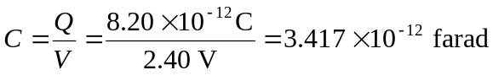
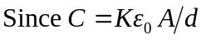for a parallel plate capacitor
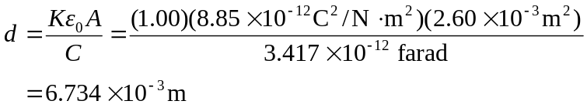
The energy density is thus

